* **Random Variables:** A random variable takes _________values that describe the __________ of a ___________ process.

The **probability distribution** of a random variable gives its ­____________________ and their ________________.

Roulette: Let X = winnings from a $100 bet on black

|  |  |  |
| --- | --- | --- |
| **X** | **+$100** | **-$100** |
| **P(X)** |  |  |

* regular variable:

**Notation:**

* random variable:
* **Notation:**
* Expected Frequency
* If I were to play roulette 1000 times, how many times would black be expected to win?
* Expected Value
* If I were to play roulette 1000 times, what would my average winnings be per play?

**Expected Value:** the _____________ value of a chance process, after repeating ___________________.

* **interpret** the expected value of playing roulette (-$2.80):
* _____________________, the _____________ winnings for roulette is actually a ________________________.

**Note:** Losing $2.80 is _______a possible outcome for ____________________(+/- $100 are the only outcomes). The expected values tells you the ___________________ over many trials, not the result of a single trial.

* **For discrete random variable with probability distribution**

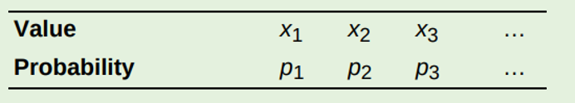

**E(X)=**

Example 1: You play a coin toss game. Heads means you get $100, tails means you lose $100. Find the expected value.

Example 2: You play a coin toss game. Heads means you get $300, tails means you lose $100. Find the expected value.

Example 3: You play a coin toss game. The coin is weighted so that there is a 75% chance of tails. Heads means you get $100, tails means you lose $100. Find the expected value.

Homework:

1. In an experiment on the behavior of young children, each subject is placed in an area with five toys. Past experiments have shown that the probability distribution of the number X of toys played with by a randomly selected subject is as follows:

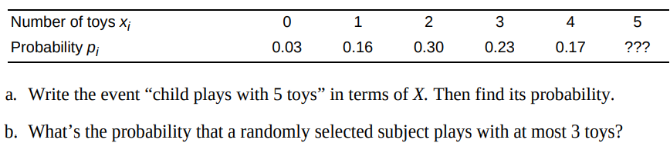

1. Faked numbers in tax returns, invoices, or expense account claims often display patterns that are not present in legitimate records. Some patterns, like too many round numbers, are obvious and easily avoided by a clever crook. Others are more subtle. It is a striking fact that the first digits of numbers in legitimate records often follow a model known as Benford’s law. Call the first digit of a randomly chosen legitimate record X for short. The probability distribution for X is shown here (note that a first digit cannot be 0). Calculate and interpret the expected value of X.

